Task 3

Project: Online Store Order Management System (PostgreSQL)

---Retrieve all orders placed by a specific customer (Emma Johnson)---

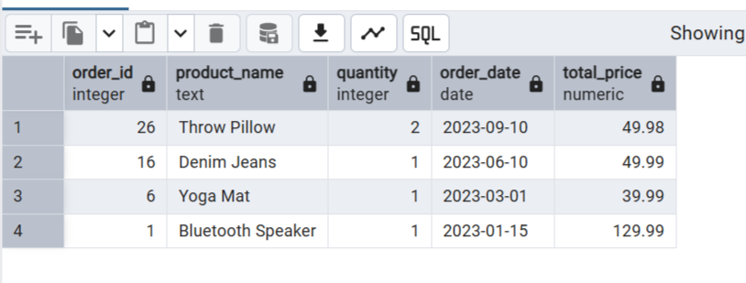

---Find products that are out of stock---

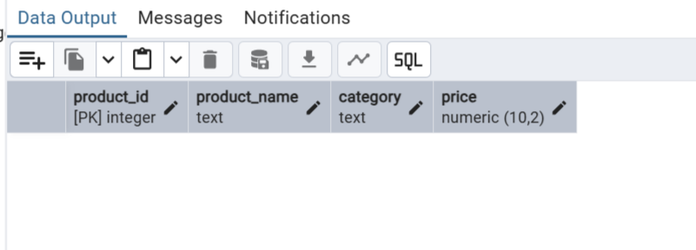

---Calculate the total revenue generated per product---

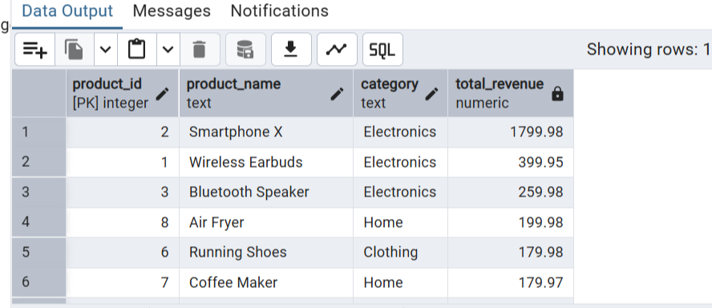

---Retrieve the top 5 customers by total purchase amount—

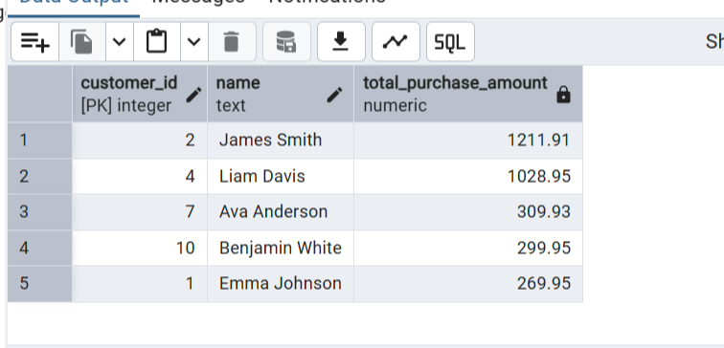

---Find customers who placed orders in at least two different product categories---

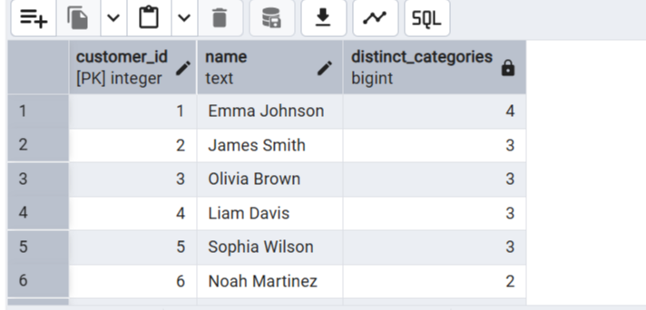

---Analytics Queries--

---Find the month with the highest total sales---

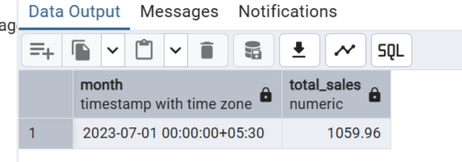

---Identify products with no orders in the last 6 months---

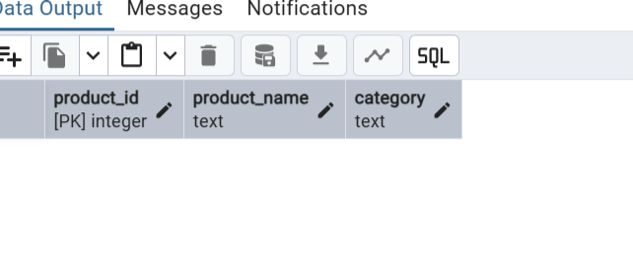

---Retrieve customers who have never placed an order---

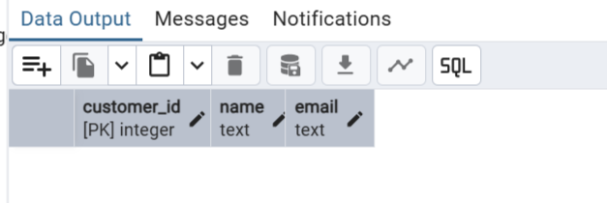

---Calculate the average order value across all orders---

